|  |
| --- |
| Report on code repository use for ISD |
| Alexander Nicholas Zacharias 21323395 |
|  |
|  |
|  |

Report on code repository use for ISD

Alexander Nicholas Zacharias 21323395

Contents

Introduction 2

Demonstration of creation of version control repository 3

Demonstration of code repository use 4

Conclusions 5

References 6

# Introduction

# Demonstration of creation of version control repository

I have created my version control repository by using the Git repository hosting system known as GitHub for the reason that I have already worked with it during one of our practical sessions and I am familiar with the interface of GitHub and how to use it. I began creating the repository by signing in to my GitHub account which I created at one of the practical sessions and went to my profile page under the “Repositories” option where I already had the repository I used in the practical session and created a new one and named it “Assesment 1”.

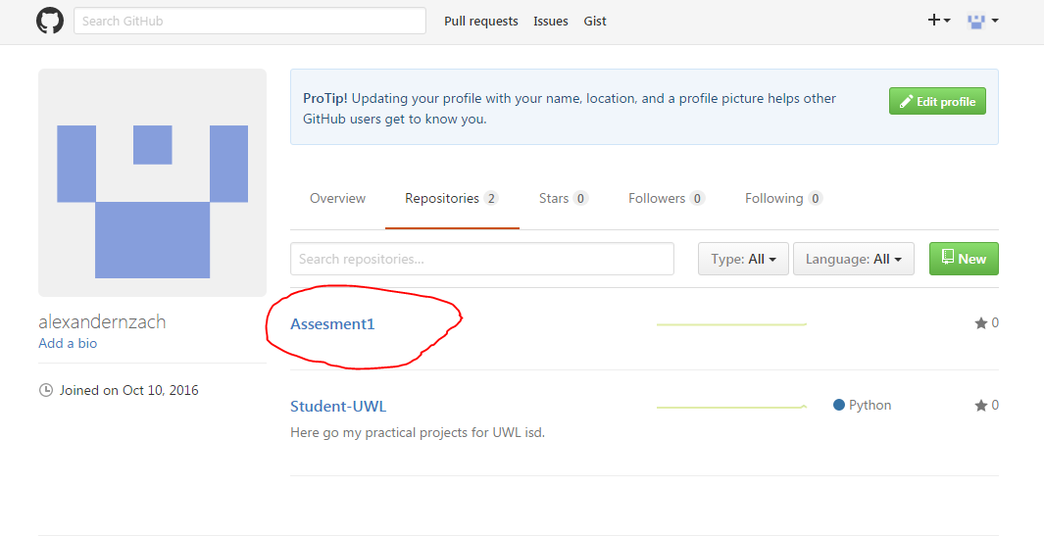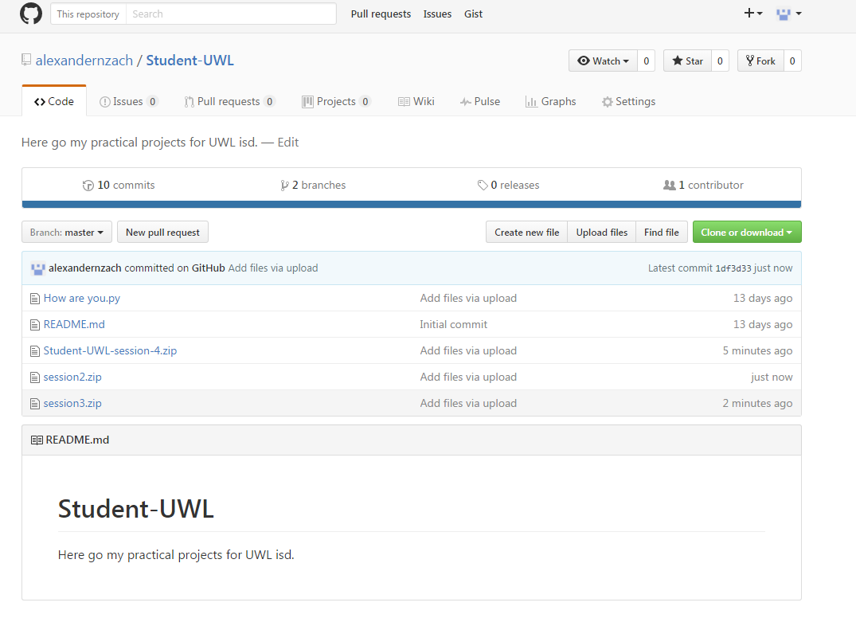

# Demonstration of code repository use

# Conclusions

In this section you briefly conclude on your experience (so far) on working with the code repository. For example, was it easy to set up, is it a hassle to use (if so, why?) or is it okay, what went particularly good? Again, keep the section concise, at max a page.

# References

http://www.howtogeek.com/180167/htg-explains-what-is-github-and-what-do-geeks-use-it-for/

As you are encouraged to use (at least) one external literature source (or website) to talk about what code repositories are and why they are useful, you need to give a reference to this (these) source(s).

The Reference for the example source is:

Chue Hong (2015): Neil Chue Hong: Choosing a repository for your software project, web article, 2015, available at: <http://software.ac.uk/resources/guides/choosing-repository-your-software-project>

Last visited: 12.10.2015